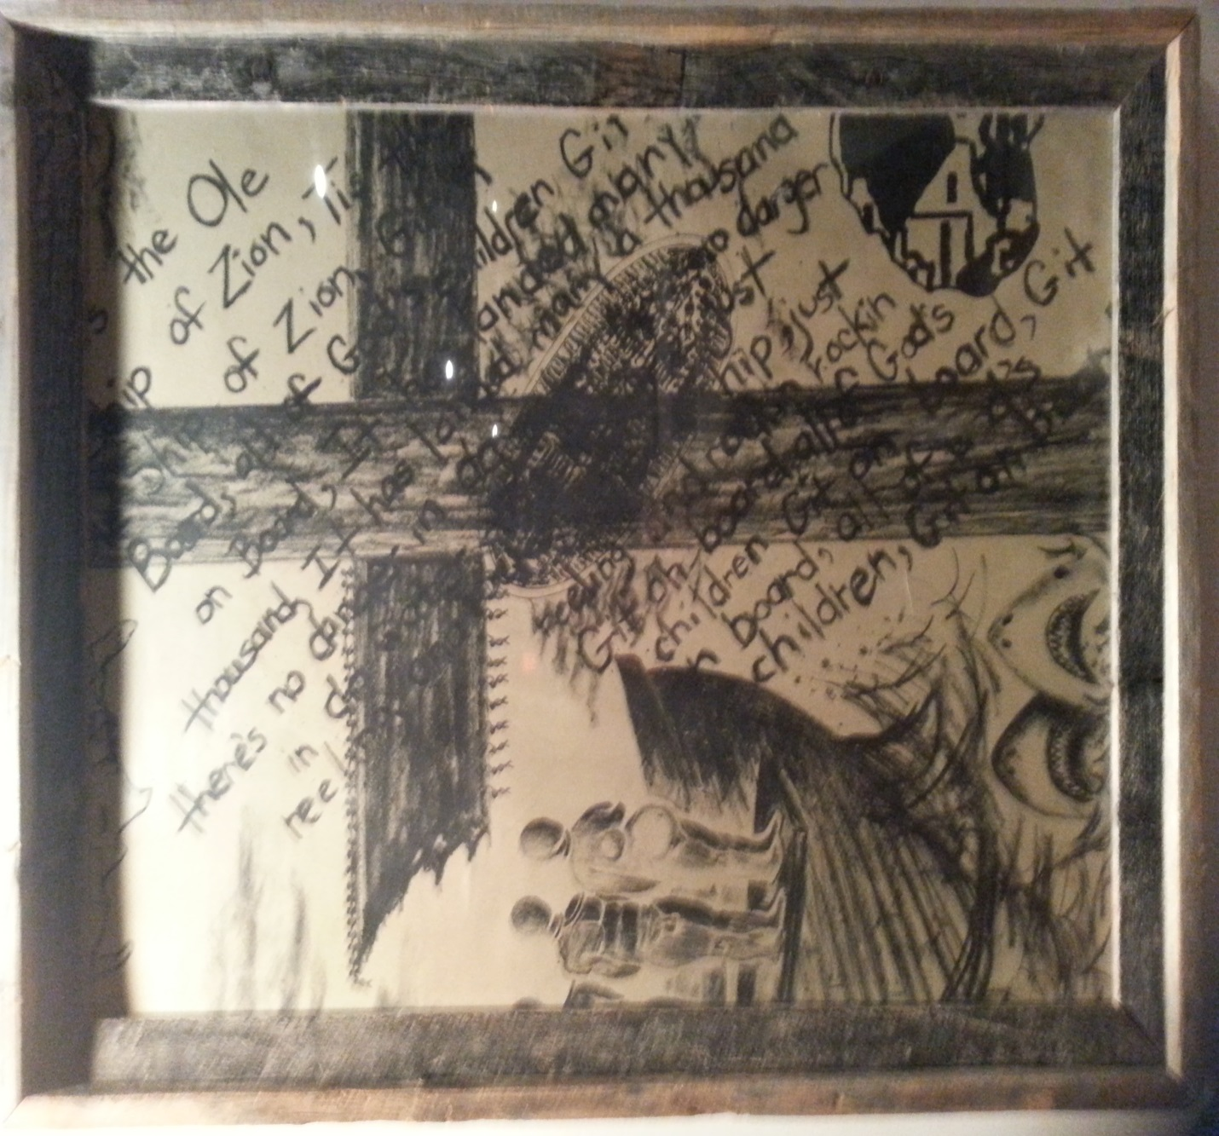

The Old Ship of Zion

The Middle Passage: We Came by Ships

The transport of black Africans to the Americas by slave ship became known as the Middle Passage because it was the middle leg of the Triangular Trade route used by the European merchants.
The African slaves were viewed as cargo by the merchants and were packed into the ships with no regard to their basic human rights.
Slave ships could be either 'tight pack' or 'loose pack'. A 'tight pack' could hold many more slaves than the 'loose pack' because the amount of space allocated to each slave was considerably less, but more slaves would die on route to the Americas.
The famous diagram above shows how slaves were tightly packed into the slave ships.

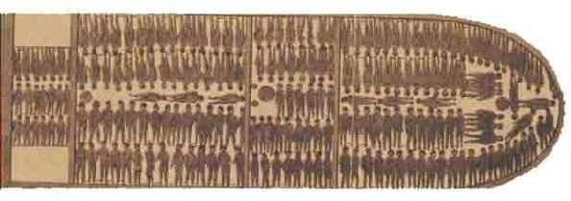

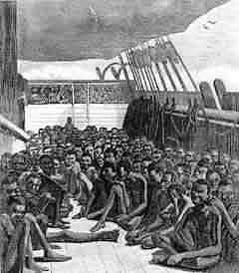
Other slaves were forced to spend the voyage sitting on deck, as on the ship 'Wildfire', pictured above.
Many slaves became seasick or developed diarrhoea. Unable to move because they were chained into their positions, the slave's deck became a stinking mass of human waste. Slaves who had developed sores where their chains had rubbed their skin, had festering wounds often with maggots eating away their flesh.
Conditions on the slave ships were so bad that many slaves decided they would prefer to die and tried to starve themselves by refusing to eat or by jumping overboard.
However, slaves that would not eat were whipped or force fed and the traders and ship owners began fixing nets to the sides of the boat so that the slaves could not jump overboard.
Slaves had no choice but to endure the horrific conditions.
The Middle Passage may have served to enrich many Europeans and Americans, but the enslaved Africans suffered extraordinary atrocities and inhuman conditions during these voyages. Estimates for the total number of Africans imported to the New World by the slave trade range from 25 million to 50 million; of these, perhaps as many as half died at sea during the Middle Passage experience. The journey from Africa to North America could take between thirty and ninety days. The vessels were called "loose packers" or "tight packers," where captives were laid side by side, coffin like, beneath the deck. The ships carried the stench of diseased and decaying bodies, and slavers often threw unruly Africans overboard, which lured sharks along these shipping lanes.
Slave-ship captains were given incentives for delivering only healthy, salable men and women to American slave markets. As a result, certain circumstances could lead to the mass murder of their African cargo at sea. When captives seemed too sick to survive the journey, slavers were known to hurl the weak and infirm into the sea. At other times, storms at sea or shortages of drinking water might lead to the mass execution of captives as well. In fact, records show that captains who ordered Africans overboard at sea often sought reimbursement from insurance companies for their losses.

