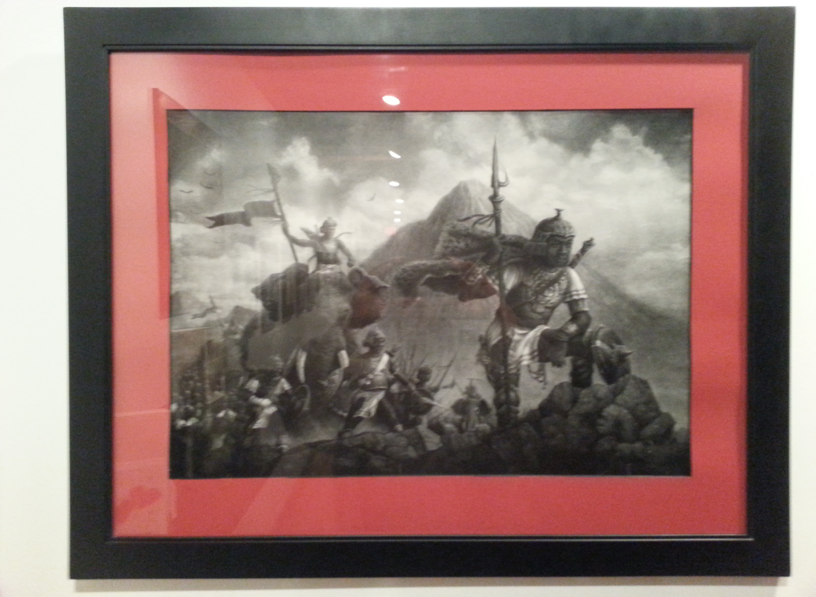

Finding A Way
Artist JGE
“We will either find a way, or make one” – Hannibal crosses the Alps

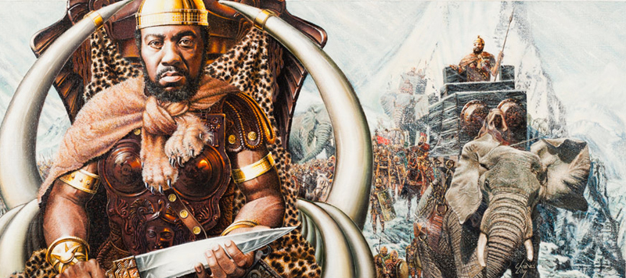

Hannibal Biography
Warrior, General (c. 247 BCE–c. 183 BCE)
Hannibal was known for leading the Carthaginian army and a team of elephants across southern Europe and the Alps Mountains against Rome in the Second Punic War.
Hannibal Barca was one of the great leaders of all time. Borrowing, to some extent, from the example of Alexander the Great—who had conquered most of the known world a century earlier—Hannibal used bold strategy and clever tactics to defeat the much larger forces of his Roman enemies. We will never know if Hannibal actually said: ‘We will either find a way, or make one’, but if Hannibal didn’t actually utter the words, then he should have done, and somebody else has quite correctly written them into history for him.
Hannibal’s greatest achievement as a leader was to hold together an army of recent recruits and half-hearted allies for fifteen years, in Italy, under the very noses of the mighty Romans who were unable to defeat him. Theodore A. Dodge, veteran of the American Civil War and author of Great Captains, published in 1889, wrote this of Hannibal:
“Hannibal earned the fidelity and love of his men by his personal qualities alone. When we consider the heterogeneous elements of which his army was composed, the extraordinary hardships it underwent, the hoping against hope, the struggling against certain defeat and eventual annihilation, the toils and privation, and remember that there was never a murmur in his camp, or a desertion in his ranks . . . it may be said that Hannibal’s ability to keep his body together and fit for work shows the most wonderful influence over men ever possessed by man.”
Hannibal’s country, Carthage, had been defeated by Rome. Carthage was strategically situated on the North African coast, near modern day Tunis, where the Mediterranean narrows to a relatively small channel between the coast and the island of Sicily. Carthage was wealthy, militarily powerful and well placed to control shipping through the Mediterranean—a dangerous rival to Roman power. After the Roman victory, Carthage was forced to pay heavy financial war indemnities to Rome and was forbidden from rebuilding its navy. Hannibal’s father, Hamilcar, a leading Carthaginian general, survived the defeat and continued a successful guerrilla war against the Romans in Sicily. He developed a plan to invade Spain, ferrying troops across the Straits of Gibraltar in small boats, and to use that country as a source of manpower and resources and as a launching pad for an attack on Rome itself. It was a bold strategy that his son, Hannibal, was to implement.
Setting the agenda
One of the unmistakable signs of a great leader is that they set the agenda. Once Hannibal set out to invade Rome, it was the Romans who were always on the back foot; always reacting to the actions of Hannibal. His famous crossing of the Alps from France into northern Italy is the best-known example. Hannibal lost perhaps half of his force and most of his famous and terrifying war-elephants crossing the Alps, but he achieved his objective: the Romans were taken by surprise as an army suddenly appeared in the Northern Italy. The Roman consul who had been sent to stop Hannibal in France hurriedly sent his troops back to Italy by sea.
Hannibal defeated the Romans in his first major engagement in Italy, springing a surprise attack by a body of troops hidden in the gully of a stream. He then he took his army along the ‘impassable’ route to Rome that ran through the marshes at the mouth of the River Arno on Italy’s western coast. They marched for four days and three nights, unable to sleep except on wagons, dead animals (including the corpses of the last-remaining elephants) or on discarded packs, because there was no dry land. There were many casualties (Hannibal lost the sight of an eye because of an infection) but the invading army emerged to the south of the Roman army that had been waiting on the good road, along the Apennine Mountains, cutting them off from Rome itself. Hannibal then ambushed the Roman army as it hurried back to defend Rome, sealing off both ends of a road along the northern shore of Lake Trasimene, trapping the Romans between woods and water About 15,000 Romans, who had been unable even to form a line of battle, were killed or drowned in the lake; another 5,000 were captured; perhaps 10,000 managed to return to Rome. The entire army had been destroyed; Hannibal lost between 1,500 and 2,500 men.
The Battle of Cannae
Hannibal moved on to the fertile plains of Puglia in South Eastern Italy, threatening Rome’s wheat supply. Rome marched to meet him with an army of unprecedented size; nearly 90,000 men. The ensuing battle of Cannae is one of the masterpieces of ancient warfare. Hannibal tempted the Romans into battle on an open plain where there was no cover for one of Hannibal’s feared (and ‘treacherous’) ambushes. The wings of the opposing armies were covered, as ever, by cavalry. Hannibal’s was better, in quality and number. As the battle progressed, Hannibal, in the thick of the action, organised an orderly fall-back of the Carthaginian center. As more and more Roman troops were poured forward into the attack on the center, their room for maneuvers—evens the room to wield their weapons—became limited. The Carthaginian cavalry on the left wing defeated their Roman counterparts and raced along the rear of Roman army. As the Romans pressed forward, the veteran troops on Hannibal’s wings began to crowd in on their flanks: the Romans were being forced into a wedge-shaped trap that was closing around them. The attack of the Carthaginian cavalry from their rear sealed the trap. The Roman army was, quite literally, slaughtered. Only 14,000 of the 90,000 Romans escaped; 50,000 were killed and the rest were taken captive.
In the event, Rome showed her mettle in this crisis. Every man over seventeen years of age was enlisted as they began to rebuild their slaughtered armies. Engineers strengthened the city’s fortifications. Women were forbidden from crying in public. Rome would fight to the last man. A long stalemate ensued, with the Romans unwilling to risk a set-piece battle, and Hannibal unable to take Rome itself. Had Carthage supplied the requested reinforcements and siege equipment at this stage, Rome might well have fallen.
Defeated but unbowed
Perhaps Hannibal’s greatest leadership achievement was to hold his army in Italy together: by the end, very few of the original army that had set out with Hannibal from Spain remained. This natural leader of men held his army of allies and volunteers together by force of personality. In 203 BCE, Rome decided to force the issue by attacking Carthage itself. Hannibal was recalled to Africa; his army followed him even there. Hannibal was finally defeated in this battle, largely because the Numidian—allies of Carthage and suppliers of the skilled cavalry contingents so essential to Hannibal’s battle tactics—were persuaded to switch sides. The resulting Roman superiority in cavalry, and the strategic lessons that they had learned at Hannibal’s hands, won the day. The Roman cavalry defeated the Carthaginian horse and swept onto the rear of the Carthaginian army.
Hannibal survived the battle and became a successful politician, reforming the corrupt Carthaginian oligarchy so successfully that it was able to make the payments of the new reparations to Rome without increasing taxation. Rome was so alarmed by the economic resurgence of Carthage that they demanded that Hannibal be handed over; he went into voluntary exile. He helped Syria to land a force in southern Italy, but was denied his request to command troops himself. When it seemed that the Syrians would betray him to Rome, he moved to Crete and then to Asia Minor. When his latest hosts were, in their turn, persuaded to hand him over to his lifelong enemy, Hannibal took the poison that he had kept always with him, hidden in a ring. He was sixty-four years old.

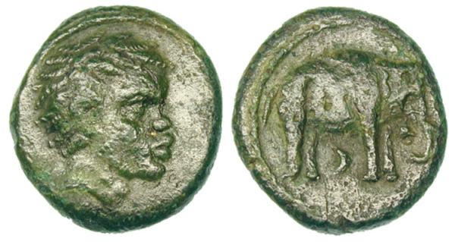

There is no picture of Hannibal in existence today. The coin above is frequently presented by commentators as a representation of Hannibal and his legacy of tamed elephants. While this writer was not able to find an academic source for this coin to confirm its date -- which was more than 2,000 years ago. The existence of such coinage during some point during our common age is no surprise in light of Hannibal's historical legacy.

Great leaders are single-minded, persistent and inventive. They create followers by example and by the force of their personality.
“If you cannot find a way; make a way.”

