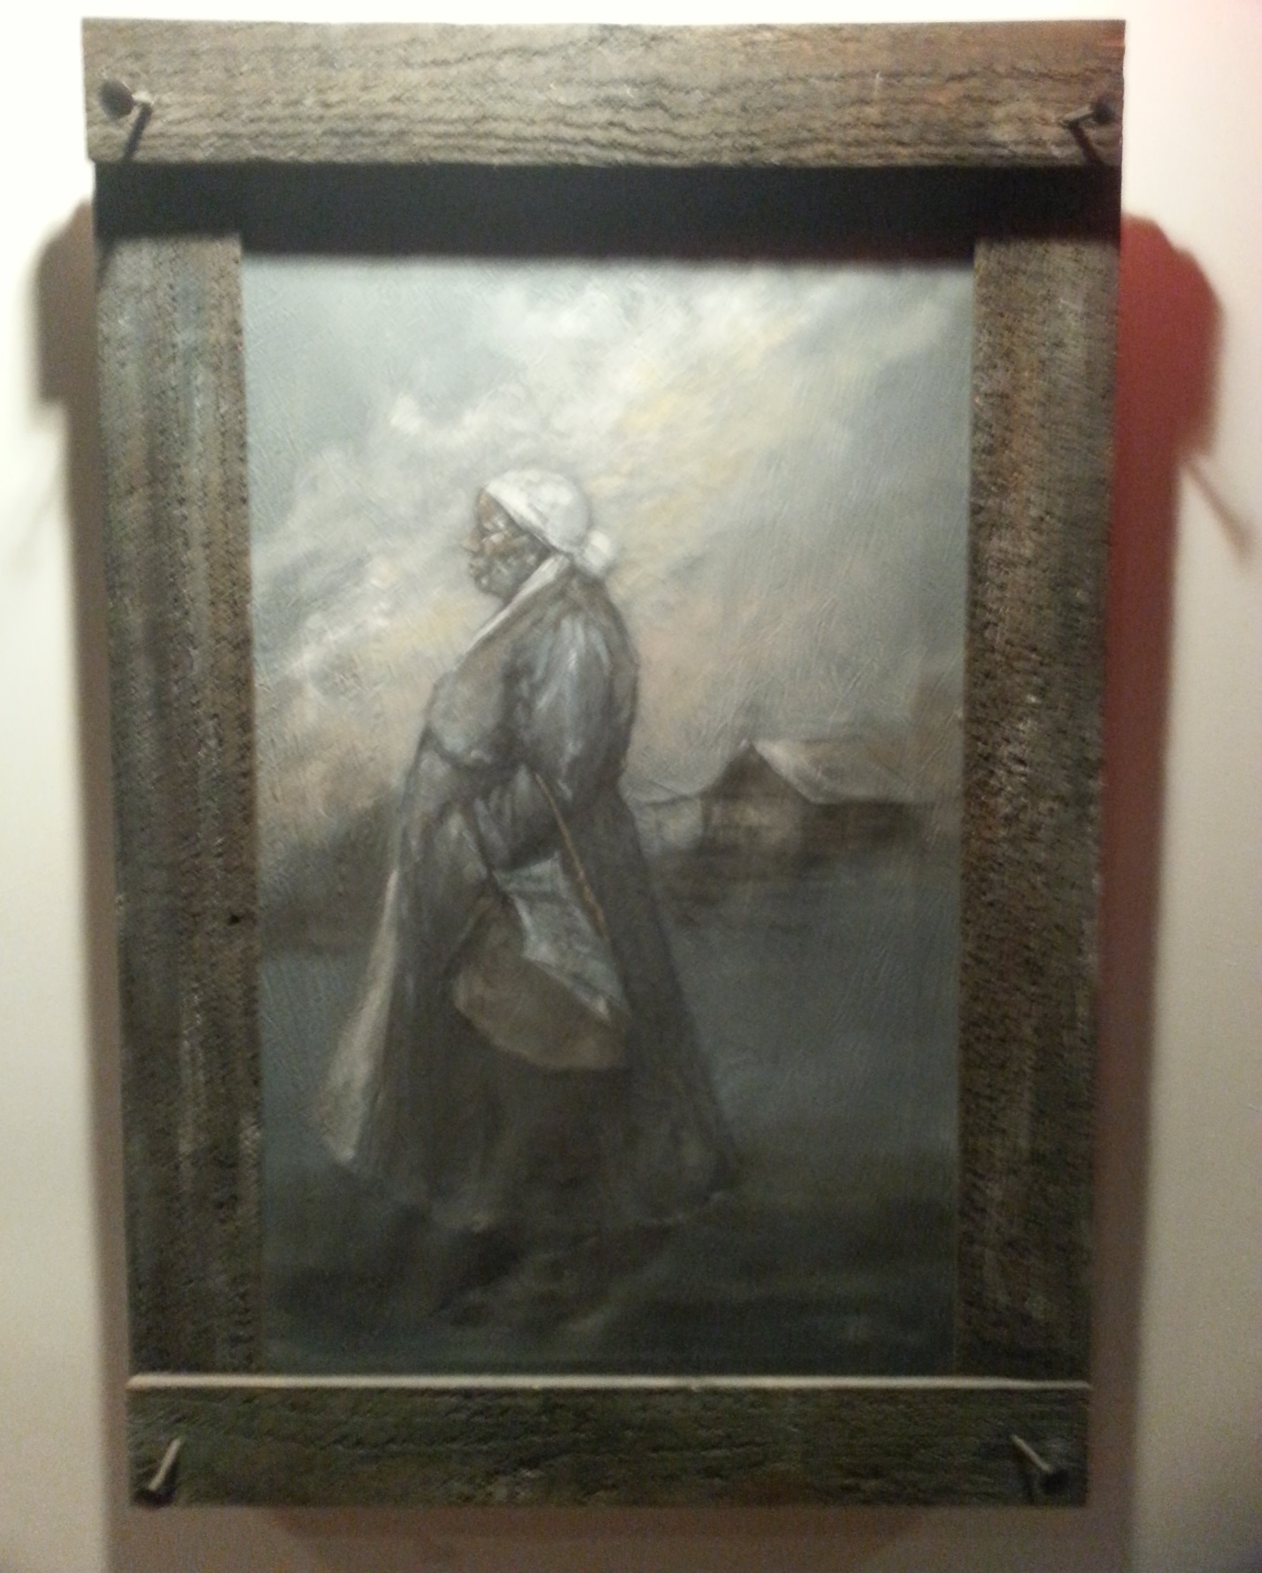

Voting Rights
Angel Weber

Time line of the Legal History of Voting Rights in America

1776

Although the Declaration of Independence has just been signed and the United States’ independent status has not yet been recognized by many countries, the right to vote begins in America as a legal privilege almost exclusively available to white, property-owning, Protestant men.

1788

With the ratification of the Constitution, all slaves are counted as 3/5’s of a single person on the national census.

1790

Only white male adult property-owners have the right to vote.

The Naturalization Act bars all persons of Asian descent from becoming naturalized. Only “free white” immigrants are recognized as eligible for naturalization.

1792

New Hampshire becomes the first state to eliminate its property requirements, thereby extending the right to vote to almost all white men.

1807

Women lose the right to vote in every state in the US for the next 113 years.

1810

Last religious prerequisite for voting is eliminated.

1828

Maryland becomes the last state to remove religious restrictions when it passes legislation enfranchising Jews. White men can no longer be denied the right to vote on the basis of their religion.

1848

The Treaty of Guadalupe-Hidalgo renders the lands now known as Arizona, California, New Mexico, Texas, and Nevada US territory. All Mexican persons within these territories are declared US citizens, but simultaneously denied the right to vote by English proficiency, literacy, and property requirements along with violence, intimidation, and racist nativism.

1856

North Carolina becomes the last state to eliminate its property requirements. The right to vote is extended to all white men in America.

1857
In the landmark case Dred Scott v. Sandford, the US Supreme Court rules that “a black man has no rights a white man is bound to respect.” African Americans are further deprived of the right to citizenship and, by extension, the right to vote.

1867

1866 Civil Rights Act of 1866 grants citizenship, but not the right to vote, to all native-born Americans.

1869

Congress passes the Fifteenth Amendment giving African American men the right to vote.

1870

The 15th Amendment is passed. It gives former slaves the right to vote and protects the voting rights of adult male citizens of any race.

1890

Mississippi adopts a literacy test to keep African Americans from voting. Numerous other states—not just in the south—also establish literacy tests. However, the tests also exclude many whites from voting. To get around this, states add grandfather clauses that allow those who could vote before 1870, or their descendants, to vote regardless of literacy or tax qualifications.

1896

Louisiana passes "grandfather clauses" to keep former slaves and their descendants from voting. As a result, registered black voters drops from 44.8%...

1920

The 19th Amendment guarantees women's suffrage.

1924

Indian Citizenship Act grants all Native Americans the rights of citizenship, including the right to vote in federal elections.

1940

Only 3% of eligible African Americans in the South are registered to vote.
Jim Crow laws like literacy tests and poll taxes were meant to keep African Americans from voting.

1964

Poll taxes are outlawed with the adoption of the 24th Amendment.

1965

More than 500 non-violent civil rights marchers are attacked by law enforcement officers while attempting to march from Selma to Montgomery, Alabama to demand the need for African American voting rights.

President Lyndon B. Johnson signs the Voting Rights Act into law, permanently barring barriers to political participation by racial and ethnic minorities, prohibiting any election practice that denies the right to vote on account of race.

By the end of 1965, 250,000 new black voters are registered, one third of them by federal examiners.

The Voting Rights Act protects the rights of minority voters and eliminates voting barriers such as the literacy test. The Act is expanded and renewed in 1970, 1975, and 1982.

1966

The Supreme Court, in Harper v. Virginia Board of Elections, eliminates the poll tax as a qualification for voting in any election. A poll tax was still in use in Alabama, Mississippi, Texas, and Virginia.

1970

President Richard Nixon signed an extension of the Voting Rights Act.

Literacy requirements are banned for five years by the 1970 renewal of the Voting Rights Act. At the time, eighteen states still have a literacy requirement in place. In Oregon v. Mitchell, the Court upholds the ban on literacy tests, which is made permanent in 1975. Judge Hugo Black, writing the court's opinion, cited the "long history of the discriminatory use of literacy tests to disenfranchise voters on account of their race" as the reason for their decision.

1972
Barbara Jordan of Houston and Andrew Young of Atlanta become the first African Americans elected to Congress from the South since Reconstruction. (Video)

1975

President Gerald Ford signed an extension of the Voting Rights Act.

1982
President Ronald Reagan signed a 25-year extension of the Voting Rights Act.

1990

Due, in part, to the enforcement of the Voting Rights Act, the number of black elected officials in Georgia grows to 495 in 1990 from just three prior to the VRA.

1995

Federal Voting Standards and Procedures Act requires states to streamline registration, voting, and other election procedures.

2003

Federal Voting Standards and Procedures Act requires states to streamline registration, voting, and other election procedures.

2006

Congress extended Section 5 of the Voting Rights Act for an additional 25 years.

2010 to Present

Since 2010 alone, the Department of Justice has had 18 Section 5 objections to voting laws in Texas, South Carolina, Georgia, North Carolina, Mississippi and Louisiana. (video)

2011

A record number of restrictions to voting were introduced in state legislatures nationwide, including photo ID requirements.

Florida passed a law that restricts voter registration and made cuts to early voting. The majority of African Americans in Florida.

Under the VRA, the DOJ blocked South Carolina's voter ID law, saying it discriminates against minority voters.

South Carolina passed a restrictive voter ID law that would keep more than 180,000 African Americans from casting a ballot.

Restrictions to voting passed in South Carolina, Texas and Florida are found to disproportionately impact minority voters.

2013

In Shelby County v. Holder, the Supreme Court strikes down Section 4 of the Voting Rights Act, which established a formula for Congress to use when determining if a state or voting jurisdiction requires prior approval before changing its voting laws. Under Section 5 of the act nine—mostly Southern—states with a history of discrimination must get clearance from Congress before changing voting rules to make sure racial minorities are not negatively affected. While the 5–4 decision did not invalidate Section 5, it made it toothless. Fallout from the ruling was swift, with several states quickly moving to change their voting laws

2014

In January 2014, a bipartisan group of legislators in Congress took the first step toward developing a new formula and modernizing the Voting Rights Act.

In response to the Shelby County v. Holder ruling, several states, including Texas, North Carolina, Wisconsin, Ohio, Alabama, Mississippi, Virginia, and South Carolina, passed laws that limited voting times or required photo ID at the polls. In October, the U.S. Supreme Court blocked law a photo ID law in Wisconsin. The Court, however, in September overturned a federal appeals court ruling that restored a week of early voting and allowed same-day registration in Ohio

2015

A federal appeals panel ruled in August that Texas's voter ID law, which was passed in 2011, discriminates against blacks and Hispanics and violates Section 2 of the Voting Rights Act of 1965. The panel ordered a lower court to re-evaluate if the law was in fact written with discriminatory intent and to fix it if it was passed under such circumstances.

