War Drummer: Call to the 12 Tribes
Artist Unknown
Ebony Wood

In Africa, the drum was used at ceremonies to pay homage to the Creator and the ancestors, to herald the home-going of a loved one, to spark courtships, to announce marriages and births, to accompany religious rites and initiation rituals and to herald political and social events. The drum was also used for war to; announce the onset of war, stir up emotions in a battle and inspire excitement and passion or to announce the triumph of battle. Without a drummer to establish communications and keep order among the units in the field, many campaigns would have ended in failure. The drummer had many responsibilities; including using one of many drum calls for everything from assembling officers for strategy meetings to sounding retreat in the midst of severe enemy fire. A drummer could always be seen near a high ranking officer because at any time he might be needed to alert the troops of an upcoming movement or operations.
Drummers have been used in U.S. military battles since the War of Independence, and Ironically, there were many African American “Drummer Boys” in the Civil War. Here are just a few:
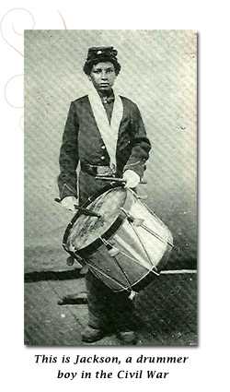
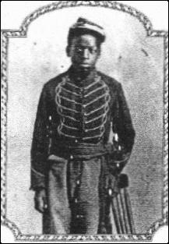. 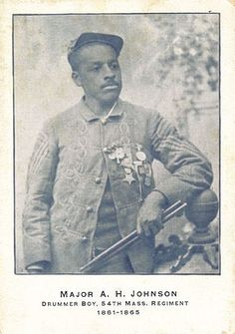

Alexander H. Johnson enlisted at the age of 16 as a drummer boy in the 54th Massachusetts Infantry. He was the first black musician to enlist during the Civil War, and is depicted as the drummer leading the column of troops on the memorial honoring Colonel Shaw and the 54th Massachusetts in front of the Massachusetts state house in Boston.

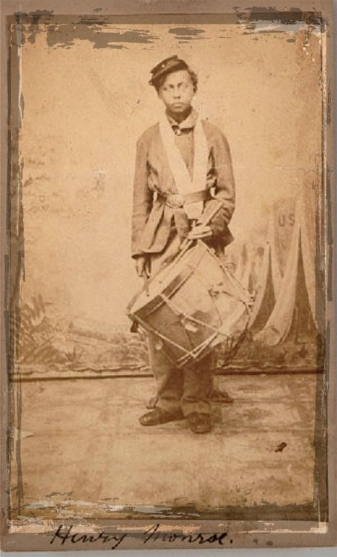
Henry Monroe was a 13-year-old drummer boy with the 54th
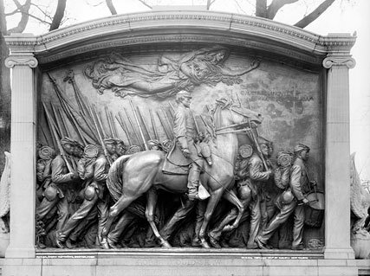

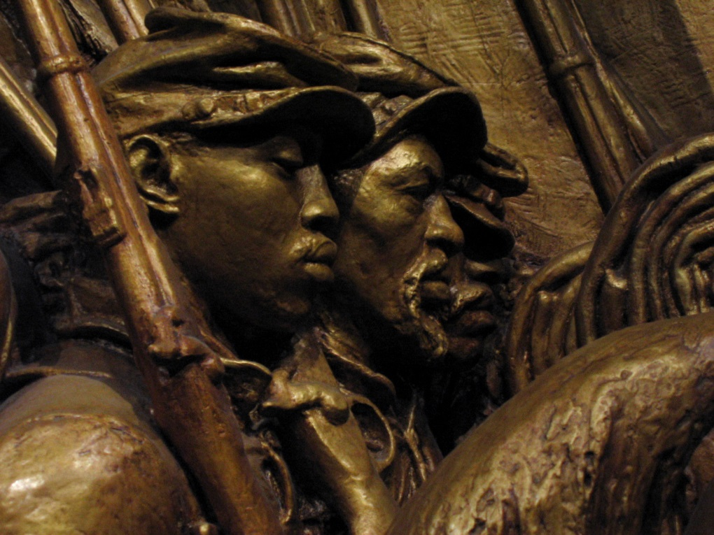
The 54 Massachusetts All Black Infantry
The drummer Alexander. H Johnson leads the infantry

The earth is Your footstool
The heavens, Your tabernacle
Righteousness, justice
Are laid as foundations of Your throne
I hear You calling me home
Disciples are dreamers
Lover are givers
You are a Father who's sending
His children out to war
I hear the lions roar
I hear war drums in the distance
Send me now
Here am I, Lord, send me
Send me out, send me out
Send me out, send me out
Send me out, send me out
I can hear Him calling
I can hear Him calling
Who will go for me?
Written by: Jake Hamilton

The 12 Tribes of Israel in History and Prophecy
by David Treybig

Who were the 12 tribes of Israel, and why are they so important in biblical history and prophecy? What do you need to know about the 12 tribes?

"...the seed shall be prosperous..."

The Bible lists 12 sons of the patriarch Israel who each became the father of a tribe of the ancient nation of Israel. Here is a list of the 12 tribes of Israel from Genesis 49:
- Reuben.
- Simeon.
- Levi (this priestly tribe did not receive a territory, and sometimes is not listed when the tribe of Joseph is listed as two separate tribes).
- Judah.
- Zebulun.
- Issachar.
- Dan.
- Gad.
- Asher.
- Naphtali.
- Joseph (often listed as two tribes named for his sons, Ephraim and Manasseh).
- Benjamin.
Let’s look at what the Bible tells us about the history and the future of the 12 tribes of Israel.

Promises made to Abraham, Isaac and Jacob
God promised Abraham that his descendants would be numerous (Genesis 13:16; 17:2; 22:17) and that his descendants would eventually constitute “many nations” (Genesis 17:4-5). He also promised Abraham that his descendants would “possess the gate of their enemies” (Genesis 22:17) and be “blessed” mightily by God (verses 16-18).
God also said that his descendants would be identified throughout history by the name of Abraham’s son, “Isaac” (Genesis 21:12). The blessings given to Abraham and Isaac were called the “birthright” blessings because they were passed on to successive generations as a right of their birth.
The “birthright” blessings given to Abraham were passed on to Isaac, who married Rebekah. Millions of people would descend from Isaac and Rebekah over time. In fact, they would number in the billions throughout the generations of humanity on the earth.
The blessing of numerous descendants who would possess the gates of their enemies was a continuation of the blessing God had promised Abraham that He would fulfill in Isaac (Genesis 17:17-19, 21). However, Abraham had a previous son, Ishmael, by Hagar, and Ishmael’s descendants were also prophesied to become numerous and constitute a “great nation” that would feature “twelve princes” (verse 20).
The “great nation” of Ishmael’s descendants today is the Arab world. The Arabs know that they are descended from Ishmael, the son of Abraham and Hagar.
If the descendants of Ishmael constitute the Arabs, the peoples who make up most of the nations in the modern Middle East, then which nations descended from Isaac? If the Bible is true, Isaac’s descendants should constitute nations more numerous, prosperous and powerful than the Arabs. The Bible is God’s truth (John 17:17)! Obviously, Isaac’s descendants in the modern world must consist of far more than just the Jews. Genesis 24:60 prophesied that Isaac’s descendants would number in the multiple millions over time.
Isaac passed his “birthright” blessings on to his son, Jacob, even though the oldest son, Esau, would normally have received them. Genesis 25:30-34 informs us that Esau “sold” his birthright to Jacob for some red stew. Then when their father, Isaac, officially passed on the birthright, Jacob deceived his father into believing he was his brother. In essence, Jacob “stole” the birthright through deception (Genesis 27).
One of the blessings Jacob received from Isaac was that other nations would bow down to the nations that would descend from Jacob (Genesis 27:29). Clearly, for this prophecy to be fulfilled, Jacob’s descendants would have to become great nations and empires. This same blessing also promised that God would bless the nations that blessed Jacob’s descendants and would curse the nations that cursed Jacob’s descendants.
God reiterated Abraham’s blessings to Jacob in Genesis 28:10-15 by saying Jacob’s descendants would be as numerous as “the dust of the earth” and they would eventually spread to all four corners of the earth from the region of the Promised Land. Jacob’s name was later changed to “Israel” (Genesis 32:28), and he had 12 sons who became the “12 tribes of Israel.”

The 12 tribes of Israel established
Before Jacob (Israel) died, he passed on the “birthright blessings” to his grandsons, who were named Ephraim and Manasseh. Israel gave prophetic blessings that were to be fulfilled in a time called “the last days” to all 12 of his sons (Genesis 49:1).
In Genesis 48:16, Israel blessed both Ephraim and Manasseh simultaneously with the words “let my name be named on them, and the name of my fathers Abraham and Isaac; and let them grow into a multitude in the midst of the earth.” Israel decreed that his own name, “Israel,” and the name of his own father, “Isaac,” would be placed upon the descendants of Ephraim and Manasseh, the two sons of Joseph, who were to each become a distinct tribe among Israel’s sons (Genesis 48:5). In doing this, Israel was giving Joseph a “double portion” among the 12 tribes of Israel.
Israel foretold in Genesis 48:19 that while the descendants of Manasseh would become a “great” people (or nation), the descendants of Ephraim would become a “multitude of nations.” Since Joseph was expanded into two tribes, this meant that there would now be 13 tribes of Israel, although they were often still known as “the 12 tribes of Israel” because the priestly tribe, the Levites, did not receive a territorial inheritance in the Promised Land.
In the blessings recorded in Genesis 49, Israel gave prophecies for each of the tribes named after his 12 sons. The 12 sons of Israel are Reuben, Simeon, Levi, Judah, Zebulon, Issachar, Dan, Gad, Asher, Naphtali, Joseph and Benjamin. The tribe most recognized by modern readers is Judah. Judah’s descendants have long been called “Jews.” However, Judah is just one of the sons of Israel. The vast majority of Israel’s descendants came from the other sons who were not called Jews.

The rise and fall of the 12 tribes of Israel
When the 12 tribes of Israel entered the Promised Land, they eventually formed the nation of Israel under David and Solomon. Soon after Solomon’s death, this empire was torn apart by a great civil war. The northern 10 tribes formed the kingdom of Israel, while the southern two tribes, Judah and Benjamin (joined by the priestly tribe of Levi), formed the southern kingdom of Judah. The northern kingdom of Israel was called “Israel” because it was led by the tribes of Ephraim and Manasseh who bore the name of “Israel” (Genesis 48:16). The southern kingdom was led by the tribe of Judah.
The kingdoms of Israel and Judah became enemies and often fought bloody wars. Though they have not reunited, they are prophesied to do so in the future. See “Israel and Judah: When Will They Be Reunited?”
The northern kingdom of Israel went into captivity in 722 B.C. because of sin and rebellion toward God. Judah was taken into captivity by the Babylonians between 604 and 586 B.C.
Just before the fall of Israel, the prophet Amos noted that the northern 10 tribes were known by the name “house of Isaac” (Amos 7:16)—just as the prophecies of Genesis 21:12 and 48:16 had predicted. The name of “Isaac” followed the 10 tribes wherever they went in their exile and later migrations.
In Jeremiah 51:5, we find a prophecy, given over a century after the 10 tribes went into captivity, that they would not be forsaken by God. Though sometimes called the “10 Lost Tribes of Israel,” these peoples are not lost to God or to students of the Bible who understand how to trace their history. To understand who some of these peoples are today, see “12 Tribes of Israel Today: Who Are They?” and “Who Are the United States and Britain in Prophecy?”

Modern significance of the 12 tribes of Israel
The 12 tribes of Israel eventually grew into great nations and empires just as God had predicted. Identifying these nations today helps us understand what will occur before Christ’s return.
Some people mistakenly think that, since the establishment of the New Testament Church, the identities of these people no longer serve any purpose. The truth is that God has many more plans for the peoples who have descended from the 12 tribes of Israel after Christ returns. For additional information, be sure to read the related articles on this site.

The Twelve Tribes of Israel represent the traditional divisions of the Jewish people in the biblical era. The tribes were Reuben, Simeon, Judah, Issachar, Zebulun, Benjamin, Dan, Naphtali, Gad, Asher, Ephraim and Manasseh. The Torah, the Jewish Bible, teaches that each tribe was descended from a son of Jacob, the Hebrew forefather who became known as Israel. Modern scholars disagree.

The Twelve Tribes in the Torah
Jacob had two wives, Rachel and Leah, and two concubines, by whom he had 12 sons and a daughter. Jacob's favorite wife was Rachel, who bore him Joseph. Jacob was quite open about his preference for Joseph, the prophetic dreamer, above all others. Joseph's brothers were jealous and sold Joseph into slavery in Egypt.
Joseph's rise in Egypt—he became a trusted vizier of the pharaoh—encouraged the sons of Jacob to move their, where they prospered and became the Israelite nation. After Joseph's death, an unnamed Pharaoh makes slaves of the Israelites; their escape from Egypt is the subject of the Book of Exodus.
Under Moses and then Joshuah, the Israelites capture the land of Canaan, which is divided up by tribe.
Of the remaining ten tribes, Levi was scattered throughout the region of ancient Israel. The Levites became the priestly class of Judaism. A portion of the territory was given to each of Joseph's sons, Ephraim and Menasseh.
The tribal period endured from the conquest of Canaan through the period of Judges until the kingship of Saul, whose monarchy brought the tribes together as one unit, the Kingdom of Israel. Conflict between Saul's line and David created a rift in the kingdom, and the tribal lines reasserted themselves.

Historical View
Modern historians consider the notion of the twelve tribes as descendants of a dozen brothers to be simplistic. It is more likely that the story of the tribes was one created to explain affiliations between groups inhabiting the land of Canaan subsequent to the writing of the Torah.
One school of thought suggests that the tribes and their story arose in the period of the Judges. Another holds that the federation of the tribal groups happened after the flight from Egypt, but that this united group didn't conquer Canaan at any one time, but rather occupied the country bit by bit. Some scholars see the tribes supposedly descended from the sons born to Jacob by Leah— Reuben, Simeon, Levi, Judah, Zebulun and Issachar—to represent an earlier political grouping of six that was expanded by later arrivals to twelve.

Why Twelve Tribes?
The flexibility of the twelve tribes—the absorption of Levi; the expansion of Joseph's sons into two territories—suggests that the number twelve itself was an important part of the way the Israelites saw themselves. In fact, biblical figures including Ishmael, Nahor, and Esau were assigned twelve sons and subsequently nations divisible by twelve. The Greeks also organized themselves around groups of twelve (called amphictyony) for sacred purposes. As the unifying factor of the Israelite tribes was their dedication to a single god, Yahweh, some scholars argue that the twelve tribes are simply an imported social organization from Asia Minor.

The Tribes and Territories

Eastern
· Judah
· Issachar
· Zebulun

Southern
· Reuben
· Simeon
· Gad

Western
· Ephraim
· Manesseh
· Benjamin

Northern
· Dan
· Asher
· Naphtali
Although Levi was dishonored by being denied territory, the tribe of Levi became the highly honored priestly tribe of Israel. It won this honor because of its reverence for Yahweh during the Exodus.

