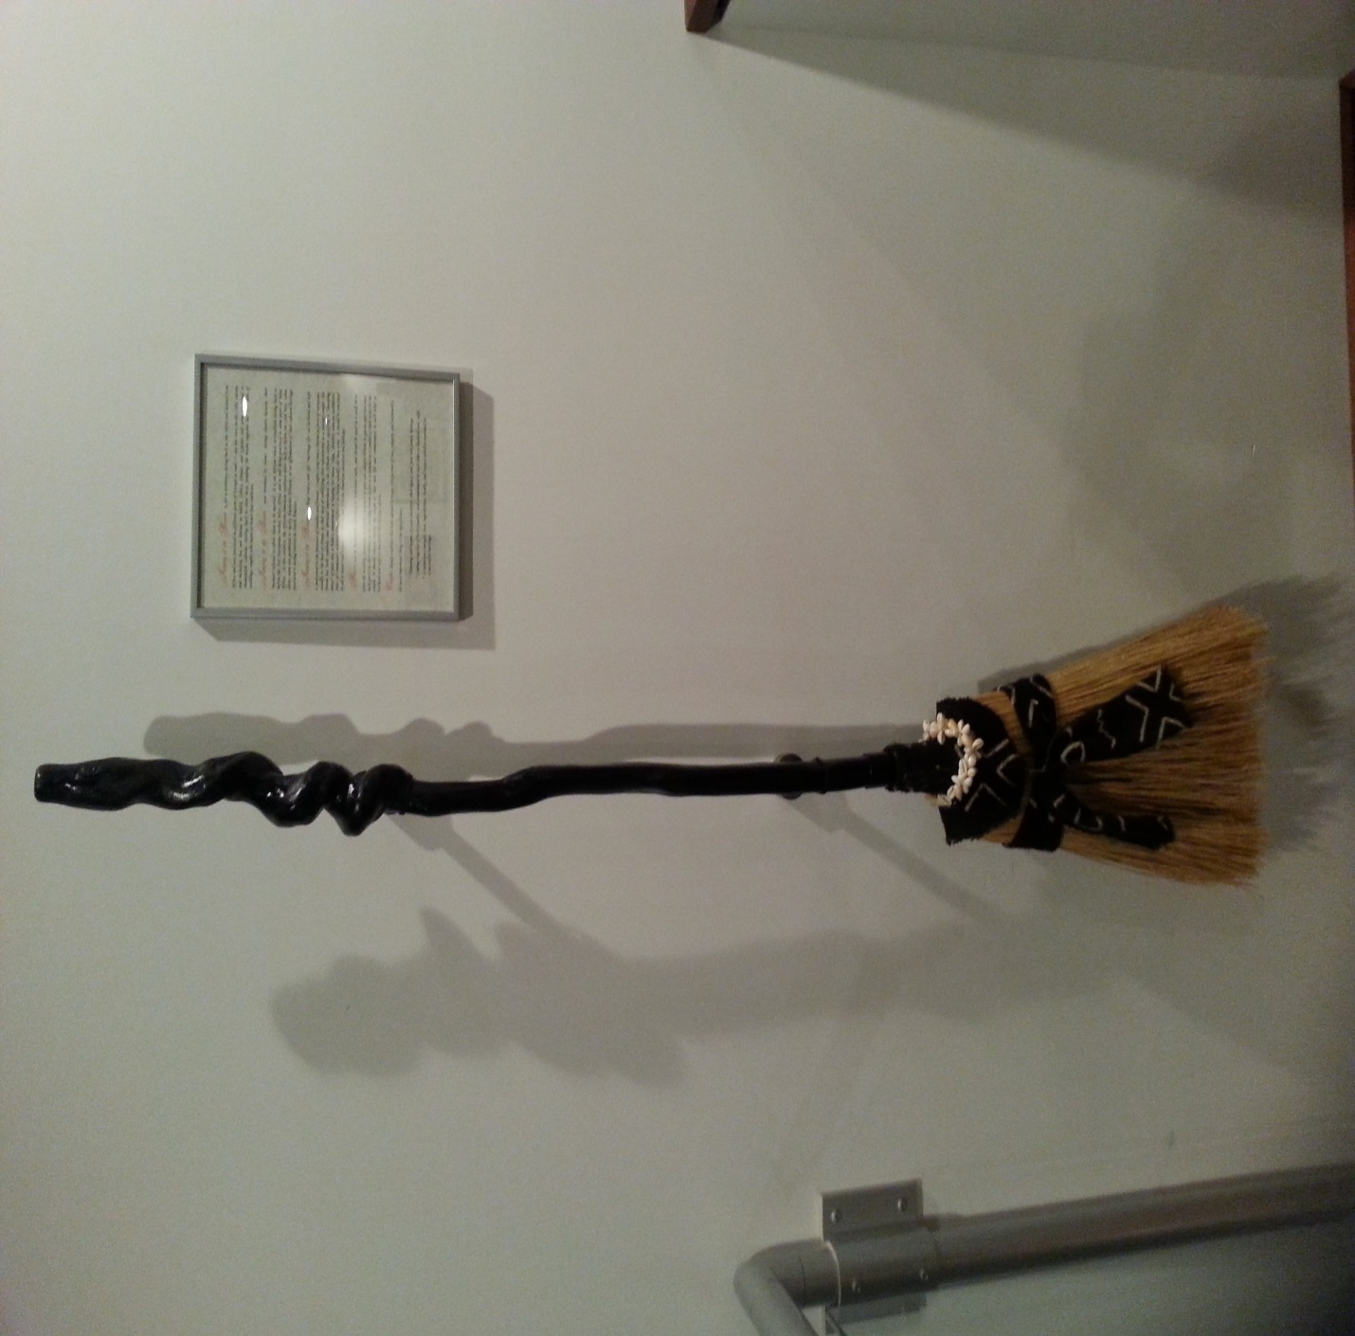

Handmade Broom for Jumping the Broom Wedding Ceremony
Artist John D. Mitchell
Material: Stained Sassafras Handle, African Kinte Cloth and Corry Shells

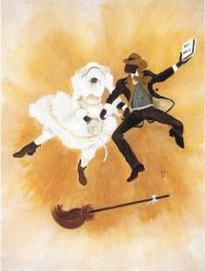

Jumping the Broom History

This is a ceremony dating back to the 1600s and derived from Africa. Dating back to slave days, jumping the broom together has been part of weddings for couples who want to honor that tradition. The jumping the broom ceremony is a wedding tradition making a popular comeback in the modern era. Full of symbolism, this ceremony has its roots in some West African tribal traditions. Interestingly, other tribal-based cultures outside of Africa have similar traditions, such as the early Celts and Druids. It has a special role in African wedding traditions, with additional symbolic meaning in the modern African-American wedding ceremony. It also has roots in the Celtic culture and including but not limited to Welsh, Celtics, Druids, and Gypsies and some aboriginal or shamanistic cultures.

Traditionally, weddings in Africa have been about the coming together of two families. It was this way centuries ago during tribe-strong eras and that focus remained well into the modern era. When a couple jumped the broom together, traditionally the act was a symbol of the two leaping forward into their new adult life and their creation of a new family by symbolically "sweeping away" their former single lives, former problems and concerns, and jumping over the broom to enter upon a new adventure as wife and husband . In addition to the traditional wedding clothing and food which were a part of the wedding, so were rituals and customs that demonstrated respect for the elder members of the family. Among those customs was the seating and feeding order of the guests.

Western weddings tend towards being bride-centric – her special day. African traditions have always been more inclusive, also honoring the newly united family and its role in helping the young bride and groom succeed in their new life together. Choosing to honor traditional African focus in a wedding with the jumping the broom ceremony is a thoughtful and considerate act, one that demonstrates a sense of maturity truly symbolic of being ready to wed.

The "Jumping the Broom" is a ceremony in which the bride and groom, either at the ceremony or at the reception, signify their entrance into a new life and their creation of a new family by symbolically "sweeping away" their former single lives, former problems and concerns, and jumping over the broom to enter upon a new adventure as wife and husband and also can be used to symbolize fertility and prosperity of the couple.
Jumping the broom or in some cases jumping over an imaginary line is an African ritual, or tradition still being practiced in some parts of West Africa. Jumping the broom is not associated with slavery. Enslaved Africans, as an affirmation of their cultural heritage practiced it during slavery in North America.
This "leap" into a new life (marriage as wife and husband is performed in the presence of families and friends. You can be as creative as you want when planning for this special ceremony.

The broom has both symbolic and spiritual importance in the African culture. The ritual itself was created by our ancestors during slavery. Because slaves could not legally marry, they created their own rituals to honor their unions. Some say broom jumping comes from an African tribal marriage ritual of placing sticks on the ground representing the couple's new home. The straws of the broom represent family; the handle represents the Almighty; the ribbon represents the tie that binds the couple together.

The broom used in the wedding ceremony has often been a beautifully handmade broom containing objects meaningful to the couple that they then keep as a momento of their wedding day and to grace the newlywed’s hearth or hallway. A fully decorated broom can be purchased at ethnic stores, online, or a regular household broom will suffice. If you decide to use your own broom and decorate it yourself, be sure it coordinates with your wedding colors. Using your own broom can also be a great bonding activity for the bridesmaids, perhaps the night, or week before the wedding.
Another idea is to have a basket full of colorful ribbon pieces at the wedding or reception and allow guests to tie ribbons around the broom before the ceremony begins. This allows the audience to participate, which is in keeping with the African tradition of community involvement.

At the conclusion of the ceremony, after the kiss and presentation of the couple to their guests, one of the attendants produces the broom or a special person from the audience brings the broom and places it in the path of the wedding couple. They then jump over the broom on their way to the recessional.

Couples celebrate this rich cultural heritage, irrespective of race, religion, and nationality. The most important thing is it's significance;
- Honoring and respect of your ancestors, their legacy, and your rich family heritage.
- Coming together of both families, and commitment to each other as wife and husband.
- It represents strength, love, togetherness, loyalty, and respect which is essential for a successful marriage.
This ceremony can also be performed at an anniversary or a renewing of vows ceremony.

