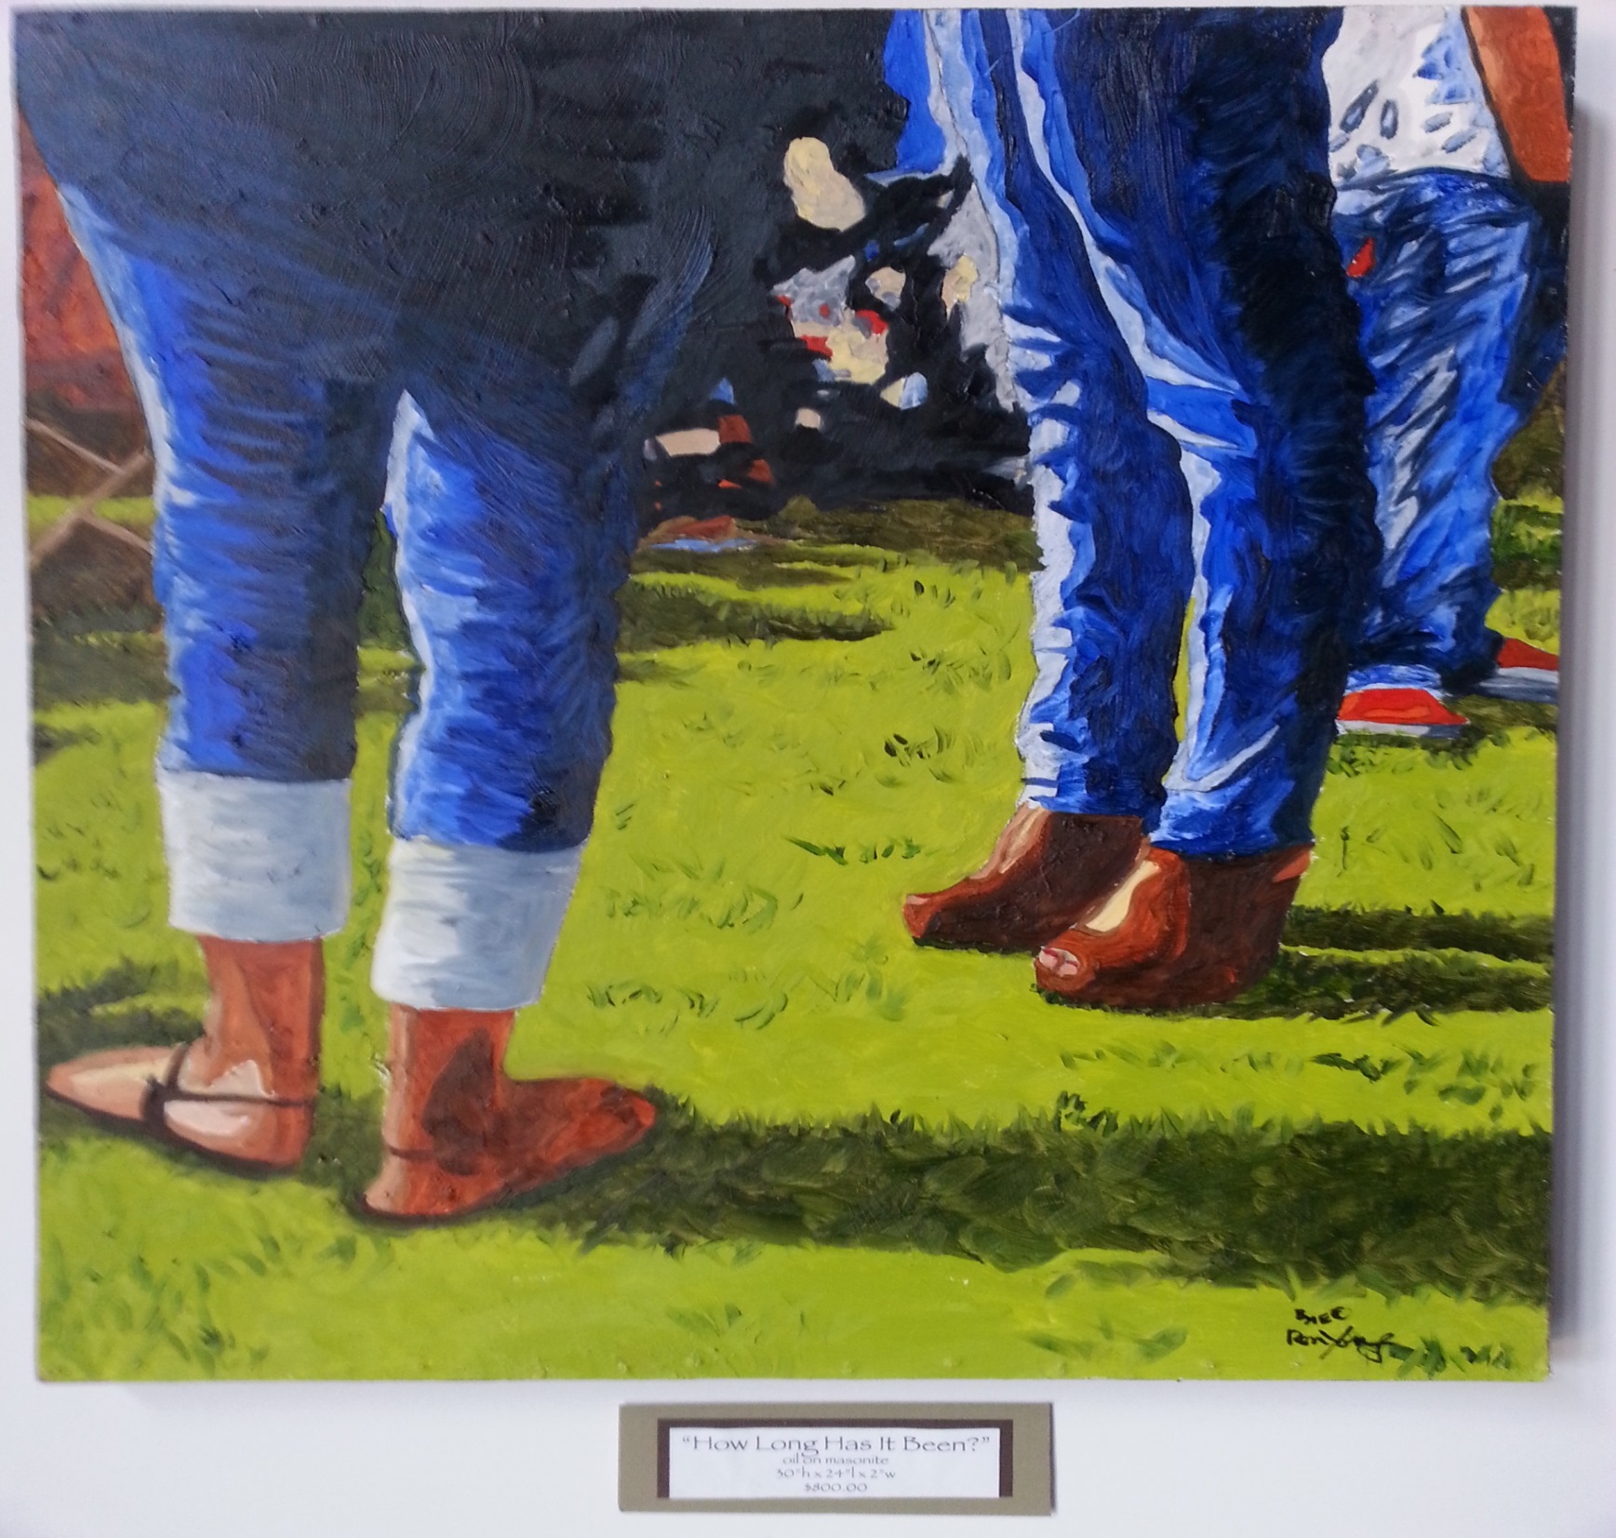

“How Long Has it Been”
oil on masonite
30”h x 24”l x 2”w
Ron Young
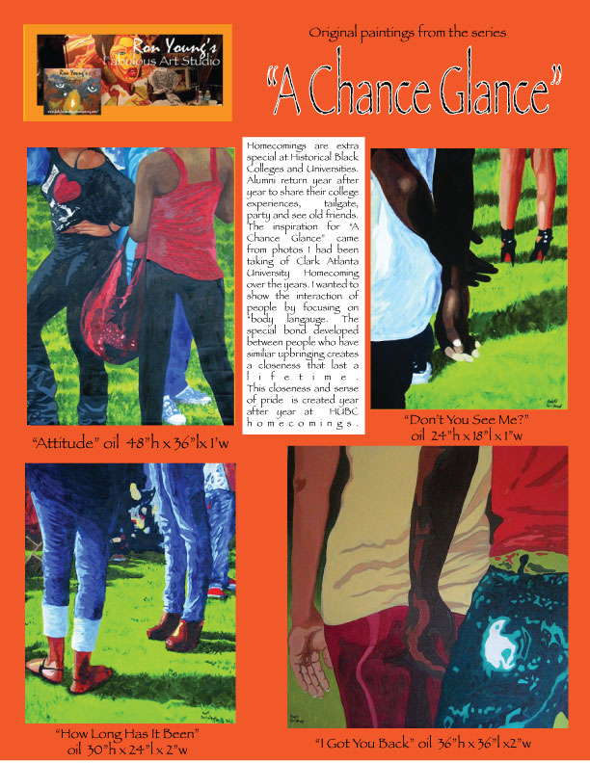

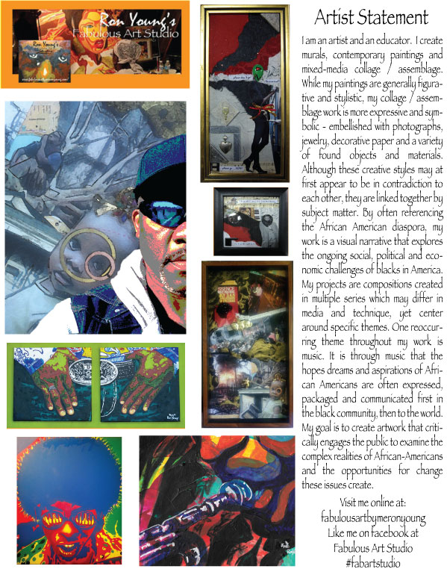

The History of Historically

Black Colleges and Universities

A tradition rich in history

The First HBCUs
Before the Civil War, higher education for African American students was virtually nonexistent. The few who did receive schooling, such as Fredrick Douglass, often studied in informal and sometimes hostile settings. Some were forced to teach themselves entirely. Some schools for elementary and secondary training existed, such as the Institute for Colored Youth, a school started in the early 1830s by a group of Philadelphia Quakers. A college education was also available to a limited number of students at schools like Oberlin College in Ohio and Berea College in Kentucky.
A Need to Improve Education
In the years following the Civil War, with the 13th Amendment’s abolition of slavery and reconstruction in the South, things began to change. In 1862, senator Justin Morrill spearheaded a movement to improve the state of public higher education throughout the United States, putting an emphasis on the need for institutions to train Americans in the applied sciences, agriculture, and engineering. The Morrill Land-Grant Act gave federal lands to the states for the purpose of opening colleges and universities to educate farmers, scientists, and teachers. Although many such institutions were created, few were open or inviting to blacks, particularly in the South. Only Alcorn State University in Mississippi was created explicitly as a black land-grant college. It would be 28 years before Senator Morrill rectified this problem. The solution came with the second Morrill Land-Grant Act of 1890, which specified that states using federal land-grant funds must either make their schools open to both blacks and whites or allocate money for segregated black colleges to serve as an alternative to white schools. Sixteen exclusively black institutions received 1890 land-grant funds.
Most of these public schools were founded by state legislatures between 1870 and 1910. Prior to this, it was the initiative of many blacks themselves, along with the support of the American Missionary Association (AMA) and the Freedmen’s Bureau, that was responsible for setting up private colleges and universities for the education of blacks. African American churches ran their own elementary and secondary education for southern blacks, preparing them for vocations or advanced studies. This created a demand for higher education, particularly for the institutes to train teachers for work in black schools. Between 1861 and 1870, the AMA founded seven black colleges and 13 normal (teaching) schools. Many of these institutions—along with the private historical black colleges and universities founded later by the AMA, the Freedmen’s Bureau, and black churches—became the backbone of black higher education, producing African American leaders for generations to come.
The Course of African American Education
Two graduates from the first generation of students to attend these new black institutions of higher learning came to the forefront in the early twentieth century, each backing a different course for the black college to take.
Booker T.Washington, a freed slave from Virginia, attended the Hampton Normal and Agricultural Institute. There, he was exposed to one of the best examples of elementary and secondary black vocational education in the nation. Hampton, founded by the AMA and the Freedmen’s Bureau, focused its efforts on preparing young blacks throughout the South to fill jobs in the skilled trades. Washington became an apprentice of Hampton’s president and decided to lead his own school after graduating. In 1881, he took the helm at the fledgling Tuskegee Institute. Tuskegee quickly became famous for its practical curriculum and focus on preparing blacks for many agricultural and mechanical trades. Washington gained notoriety and was soon a celebrity among blacks and whites as the proponent of black advancement through vocational training and racial conciliation. He believed firmly that the best way for freed slaves and other blacks to attain equality in the United States was through the accumulation of power, wealth, and respect by means of hard work in practical trades. The inscription on the Tuskegee University monument to Booker T. Washington reads, “He lifted the veil of ignorance from his people and pointed the way to progress through education and industry.”
W.E.B. DuBois took a very different view of how blacks ought to function in society. Raised in Massachusetts and first exposed to segregation during his undergraduate work at Fisk University in Nashville, Tennessee, DuBois believed that it was essential that blacks receive training not only in vocational fields, but also in the liberal arts. A fierce advocate for civil rights, DuBois feuded very openly with Washington over the proper strategy for educating black university students. DuBois felt quite strongly that Washington’s universal vocational training only perpetuated the servitude of slavery. He believed equality and a sense of purpose would only come if talented blacks were allowed to study the arts and sciences. Then they could become leaders and teachers for the next generation. It is impossible to say which of these views triumphed. Each, in its own way, lives on today in modern HBCUs. Many colleges and universities seem to be embracing both schools of thinking—students receive practical, technical training grounded in the liberal arts.
Historical Black Colleges and Universities Gain Credibility
Throughout the period of this debate, attendance at HBCUs increased substantially, as did financial support from the government and individual philanthropists such as John D. Rockefeller and Andrew Carnegie. HBCUs also gained credibility and respect when the Southern Association of Colleges and Schools began formally surveying and accrediting them in 1928.
New Challenges
Historical black colleges and universities would soon face many new challenges, though. The Great Depression and World War II left many black colleges in a financial crisis. Despite improvements in funding in previous years, most land-grant HBCUs were still dismally underfunded when compared to their white counterparts. Private HBCUs were in an even tougher bind. The depression had wiped out many of their sources of philanthropy. Fundraising was becoming very difficult and distracting administrators from issues of improving education. In 1943, Dr. Fredrick D. Patterson, president of the Tuskegee Institute, published an open letter to the presidents of private HBCUs urging them to band together, pooling their resources and fundraising abilities. The next year, the United Negro College Fund began its activities soliciting donations to private HBCUs, with far greater efficacy than any one of its member colleges alone.
Brown v. The Board of Education
Ten years later, public HBCUs and black students across the nation became the beneficiaries of the Supreme Court’s decision in the case of Brown v. The Board of Education. The court’s ruling that “separate but equal” schooling was anything but equal meant that states would be forced to better fund the HBCUs and open their other universities to black college-bound student. The case, won by lawyers trained at Howard University, didn’t bring immediate relief in many cases, as states protested the ruling. The Civil Rights Act of 1964 gave the federal government greater power to enforce desegregation.
Higher Education Act and Presidential Support
In 1965, the federal government provided aid to HBCUs through the Higher Education Act. It was followed by another important judicial decision, Adams v. Richardson. This case found ten states in violation of the Civil Rights Act for supporting segregated schools. The states were ordered to work actively to integrate institutions, so long as that integration was not carried out at the expense of HBCUs, which were deemed to play an important and unique role in the education of African Americans.
The Carter, Reagan, and Bush administrations thought that HBCUs were significant too. President Carter established a program aimed at strengthening and expanding the capacity of the historical black college or university. Reagan issued an executive order aimed at further reversing the effects of previous discriminatory treatment towards black colleges. Congress supported the Reagan order with increased federal funding to HBCUs. Reagan’s successor, George Bush, also issued an executive order, this time building on the Reagan order and establishing a commission in the Department of Education responsible for advising the president on matters regarding historically black colleges and universities.
United States v. Fordice
Another pivotal court ruling came in 1992 with the United States Supreme Court’s ruling in United States v. Fordice. The court’s decision required that Mississippi do away with the remnants of a dual, segregated system of education. This was similar to the Adams decision except that no special circumstances were outlined for the treatment of HBCUs. Supporters of black colleges worried that the decision might hurt African American students in the long run if the support and attention they received at HBCUs was taken away. Desegregation is important, in their view, but should never be viewed as a reason for putting black students in a disadvantageous situation.
The historical black college or university provides a unique education for African Americans. Students who attend HBCUs graduate with greater frequency than African American students at predominantly white universities, and these students get more academic and social support. HBCUs must be protected because they are not only an important part of our history, but also an important part of our future.
This article was written by Hannah Purnell
Hannah Purnell is a staff writer for CollegeView.com. Hannah writes extensively on the topic of undergraduate studies and the college search process.

List of HBCUs

ALABAMA
Alabama A&M University
Alabama State University
Bishop State Community College
Concordia College

ARKANSAS
Arkansas Baptist College
Philander Smith College

CALIFORNIA
Charles Drew University of Medicine & Science

DISTRICT OF COLUMBIA
Howard University

DELAWARE
Delaware State University

FLORIDA
Bethune-Cookman University
Edward Waters College
Florida A&M University
Florida Memorial University

GEORGIA
Albany State University
Clark Atlanta University
Fort Valley State University
Morehouse College
Morris Brown College
Paine College
Savannah State University
Spelman College

KENTUCKY
Kentucky State University

LOUISIANA
Dillard University
Grambling State University
Xavier

MARYLAND
Bowie State University
Coppin State University
Morgan State University

MISSISSIPPI
Alcorn State University
Coahoma Community College
Jackson State University
Mississippi Valley State University

MISSOURI
Harris-Stowe State University
Lincoln University of Missouri

NORTH CAROLINA
Barber-Scotia College
Bennett College
Elizabeth City State University
Fayetteville State University
Johnson C. Smith University
Livingstone College
North Carolina A&T State University
North Carolina Central University
St. Augustine’s College
Shaw University
Winston Salem State University

OHIO
Central State University
Wilberforce University

OKLAHOMA
Langston University

PENNSYLVANIA
Cheyney University of Pennsylvania
Lincoln University

SOUTH CAROLINA
Allen University
Benedict College
Claflin University
Clinton Junior College
Denmark Technical College
Morris College
South Carolina State University
Voorhees College

TENNESSEE
Fisk University
Knoxville College
Lane College
LeMoyne-Owen College
Meharry Medical College
Tennessee State University

TEXAS
Huston-Tillotson University
Jarvis Christian College
Paul Quinn College
Prairie View A&M University
Texas College
Texas Southern University
Wiley College

VIRGINIA
Hampton University
Norfolk State University
Saint Paul’s College

WEST VIRGINIA
Bluefield State College
West Virginia State University

